10 Best Google Maps SEO Agency in Brampton for Local Businesses
Meta Title: 10 Best Google Maps SEO Agency in Brampton (2026 List)
Meta Description: Looking for a Google Maps SEO Brampton expert? Compare 10 top local SEO agencies in Brampton, their services, and pricing before you choose one.
Focus Keyword - Google Maps SEO Agency in Brampton
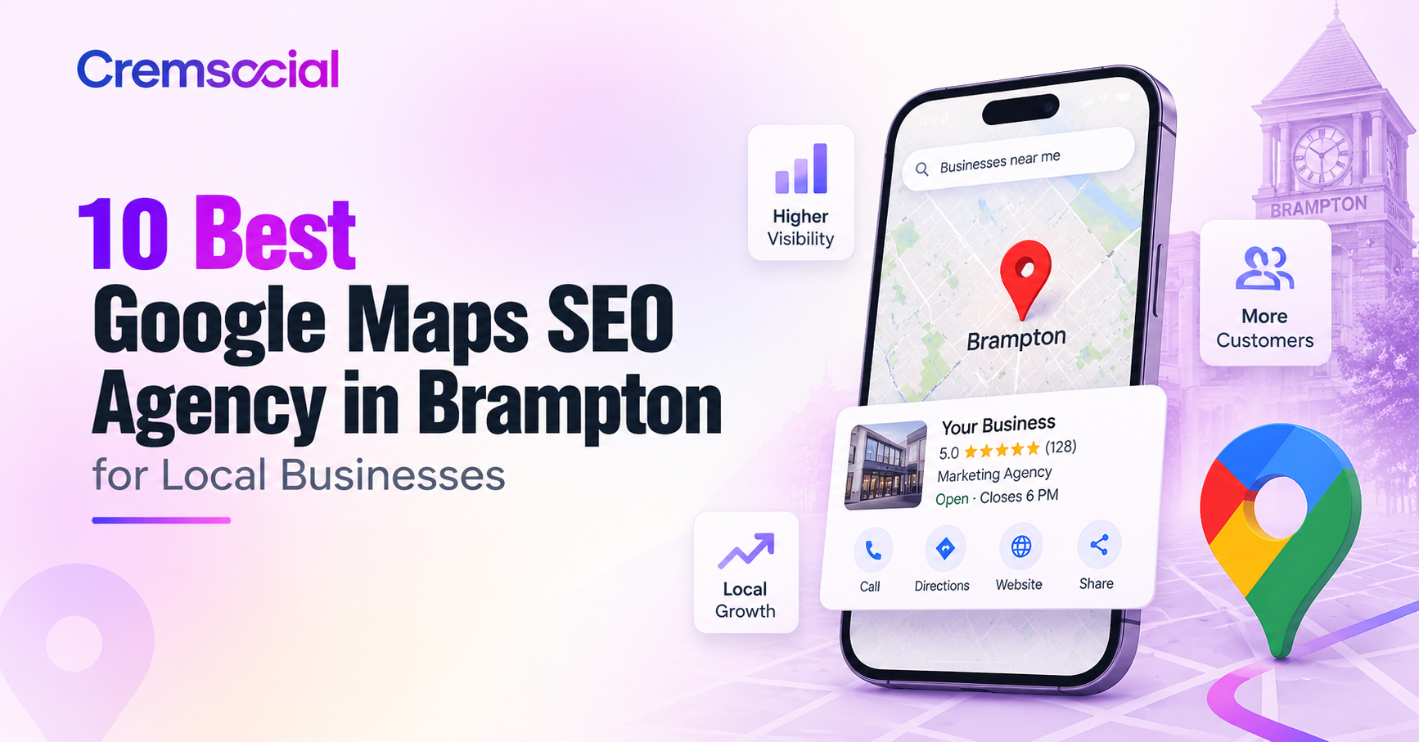
Brampton is one of the fastest-growing cities in Canada, and that growth has turned the local map pack into one of the most competitive pieces of digital real estate in the GTA. When a resident searches for a plumber, a dentist, or a restaurant "near me," the three listings that show up in Google Maps get the call — everyone else gets scrolled past. That's exactly why so many business owners start looking for a Google Maps SEO Brampton specialist instead of trying to fix their Google Business Profile on their own.
The problem is that "SEO agency" has become a crowded label, and not every local SEO agency in Brampton actually understands how the map pack works. To save you the research, we pulled together this list of ten agencies worth knowing about if you're trying to get found on Google Maps, improve your Google Business Profile SEO Brampton, or build out a broader local search marketing Brampton strategy. We're including ourselves on this list because, frankly, we think we belong here — but we've tried to describe every agency fairly based on what they actually offer.

1. Cremsocial - Best Google Maps SEO Agency
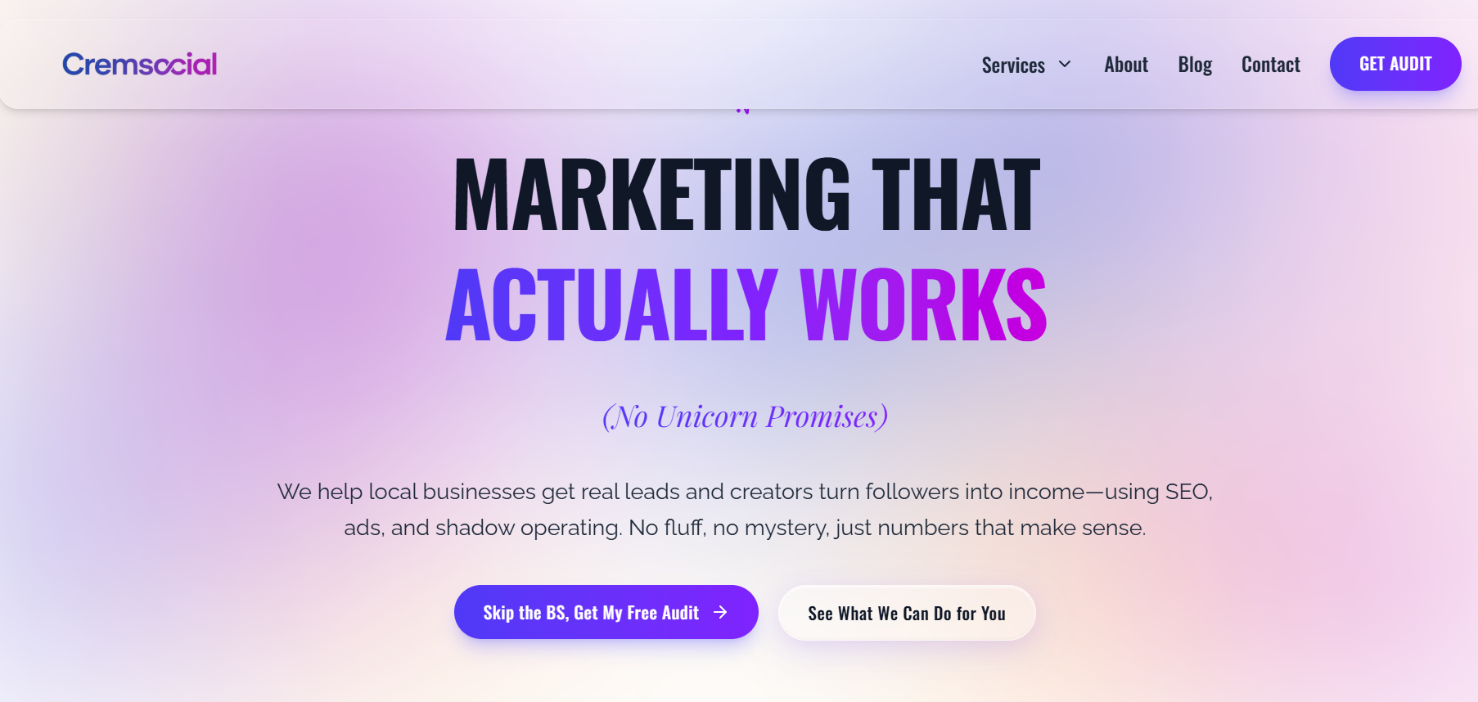
Cremsocial is a Brampton-based digital marketing agency built around one idea: marketing should produce numbers you can actually check, not vanity metrics. For local businesses trying to win the map pack, Cremsocial focuses on Google Business Profile optimization — cleaning up categories, adding the tracking needed to see which searches turn into calls, and fixing the technical site issues that quietly hurt local rankings. What sets the agency apart from a typical local SEO agency in Brampton is the reporting style: plain-English updates on what changed and what it produced, rather than a dashboard full of impressions nobody can act on.
Cremsocial also runs SEO and paid ads as part of the same engine, so a Google Maps push can be paired with landing pages and ad campaigns built to convert the extra visibility into leads. For creators and small teams who want more than a one-off audit, the agency also offers shadow operating support to turn an audience into recurring income. If you want a second opinion on your current setup, they offer a free marketing audit before you commit to anything.

2. MarketingFlow
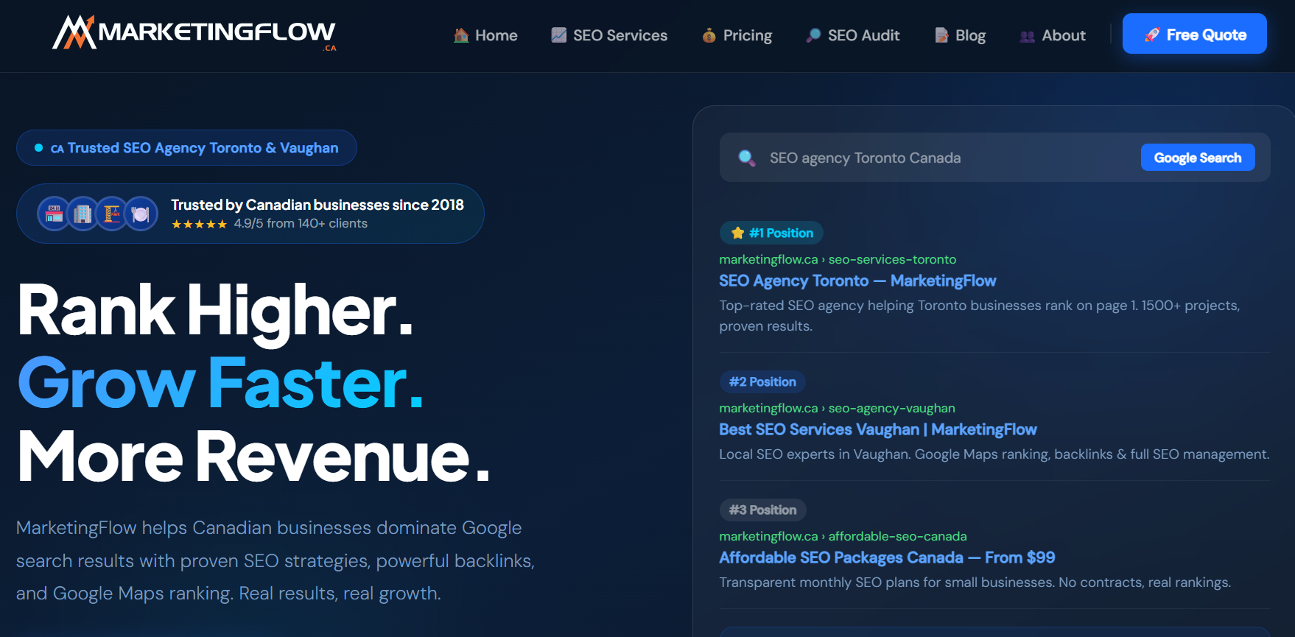
MarketingFlow is a Brampton-focused SEO agency with plans starting at $99 a month and no long-term contracts. Their Google Maps work centers on Google Business Profile optimization, schema markup, and manual outreach for editorial backlinks rather than directory spam. They publish monthly ranking reports so clients can see keyword movement directly, and they work across trades, healthcare, legal, real estate, and restaurant clients throughout Brampton.

3. Tabula
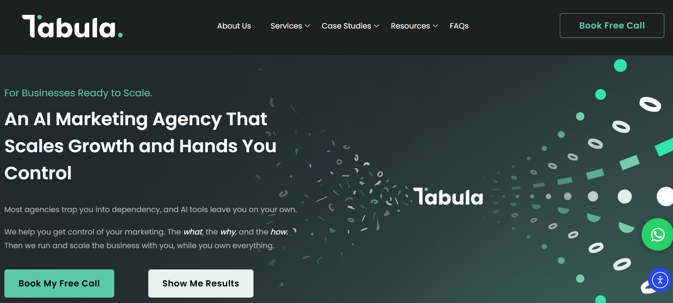
Tabula is a GTA agency that pairs traditional SEO with what it calls GEO — optimizing a business not just for Google's map pack but for AI tools like ChatGPT and Gemini. Their process for local visibility includes Google Business Profile fixes as one piece of a broader six-step system: strategic planning, execution, and weekly reporting, all run through a shared project tracker so clients can see the work in real time. Every client also owns their own accounts and data, which is worth asking about if you've been burned by an agency that holds your login information hostage.

4. RMCM
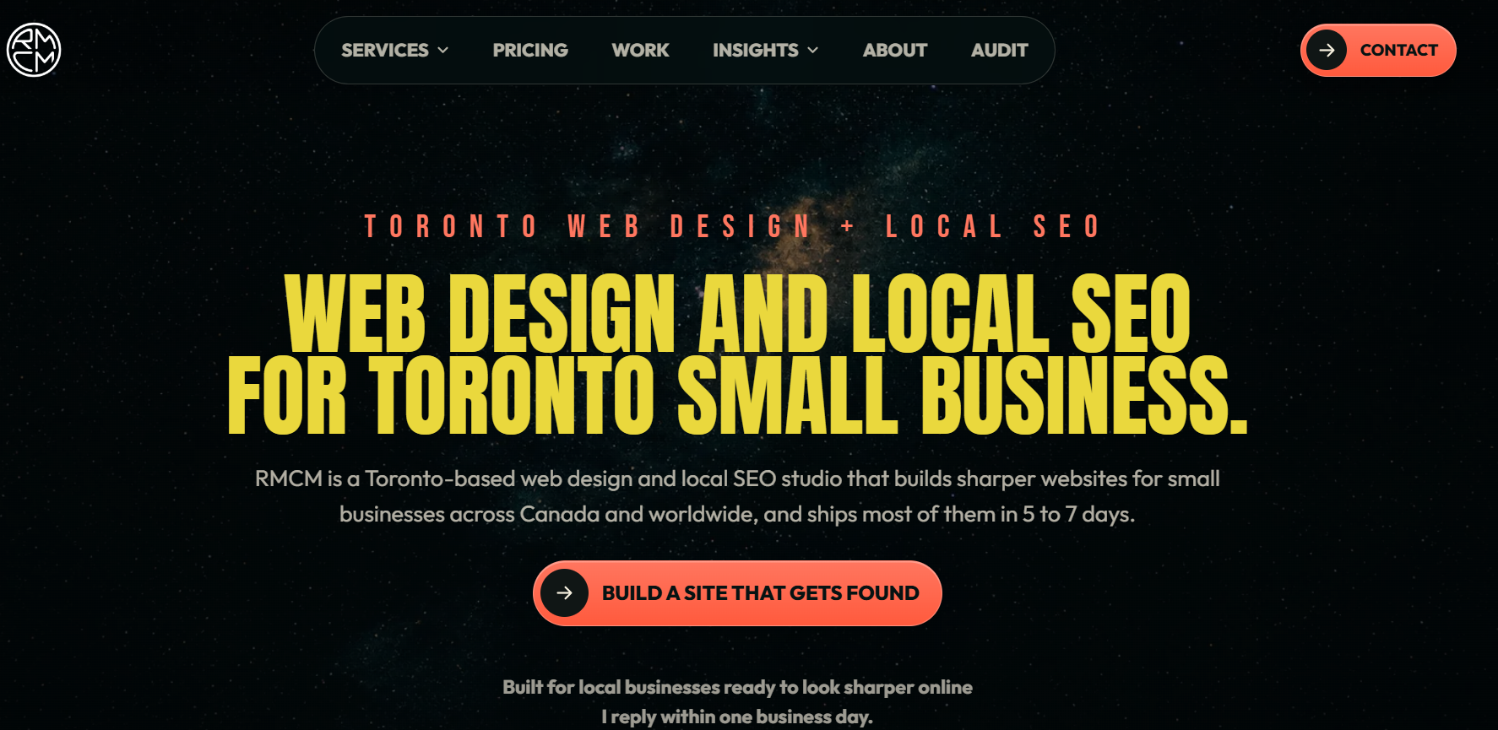
RMCM specializes specifically in map pack visibility, built around the three ranking signals Google actually uses: relevance, proximity, and prominence. As a Google Maps SEO Brampton specialist, their offer includes Google Business Profile optimization, service-area setup for trades and home-service businesses without a public storefront, citation cleanup, and a review system to build prominence over time. It's a one-time project fee rather than an ongoing retainer, which makes it a reasonable entry point if you specifically want your Google Maps ranking services Brampton fixed without signing up for a monthly plan.

5. Matt Edward SEO
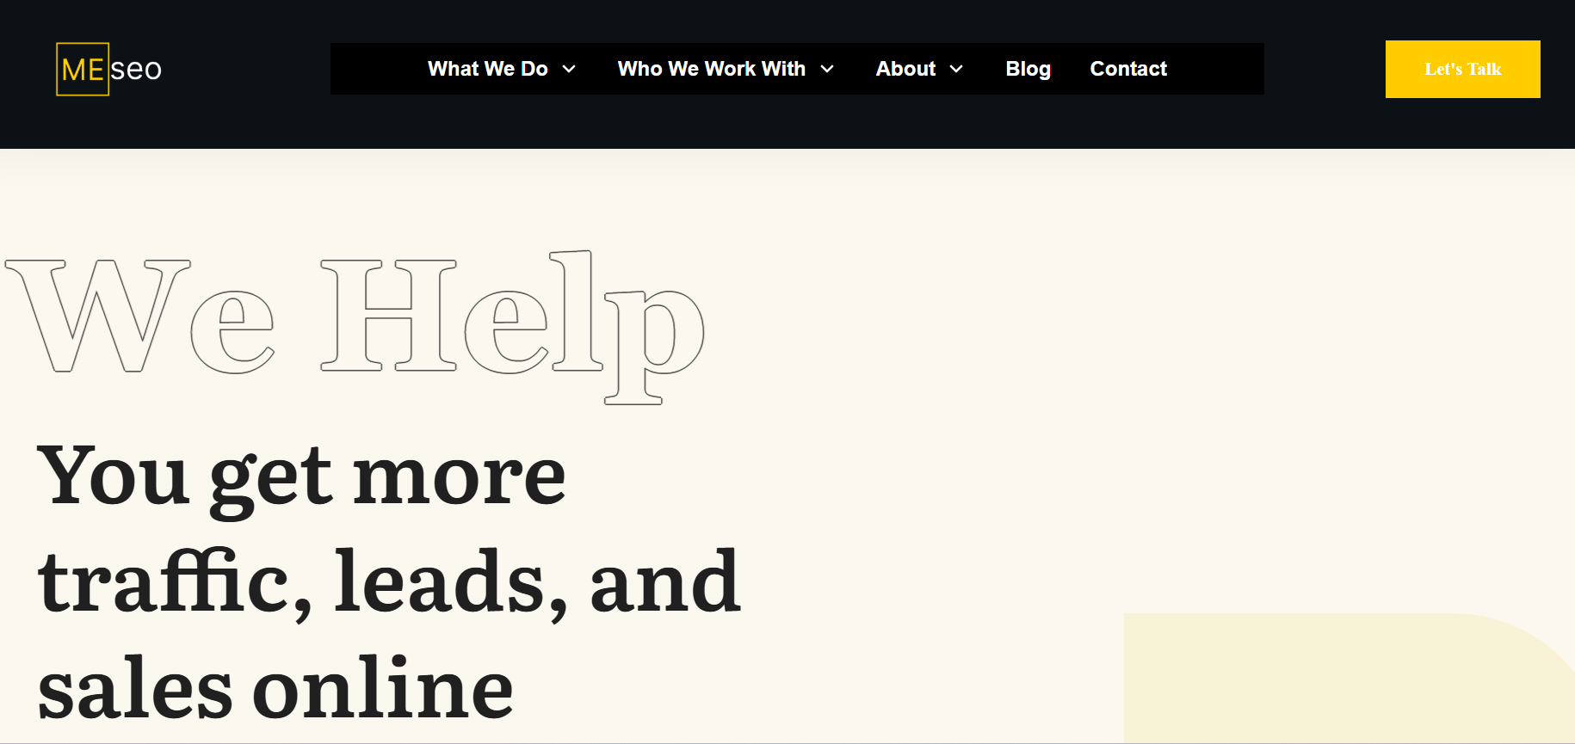
Matt Edward SEO is run by an individual consultant serving Brampton and several other Canadian cities. The approach leans heavily on a thorough audit process (the site claims over 140 checkpoints) covering keyword research, on-page fixes, off-page link building, and Google Business Profile work. It's worth noting this is a solo operation rather than a full team, which can mean more direct communication but less bandwidth for larger accounts.

6. M. Lopez Agency
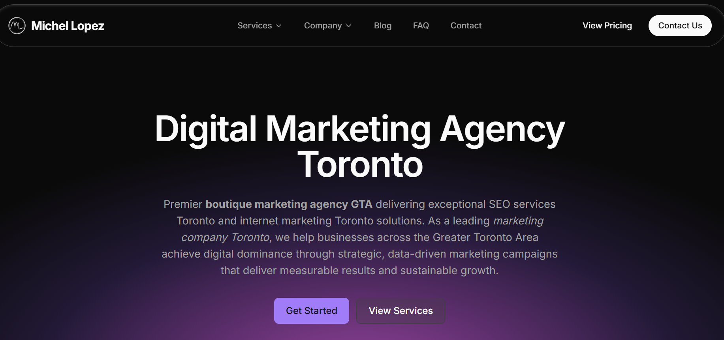
M. Lopez is a Toronto-based boutique agency that runs a dedicated Brampton SEO program, with location-specific strategies built around Brampton's business districts — Downtown, Bramalea City Centre, and Mount Pleasant Village among them. Their local SEO work includes Google Business Profile management across Brampton's postal codes, multilingual content for the city's South Asian communities, and mobile-first optimization aimed at commuters. They also run PPC, web design, and content marketing services alongside their SEO offering.

7. AdLynk
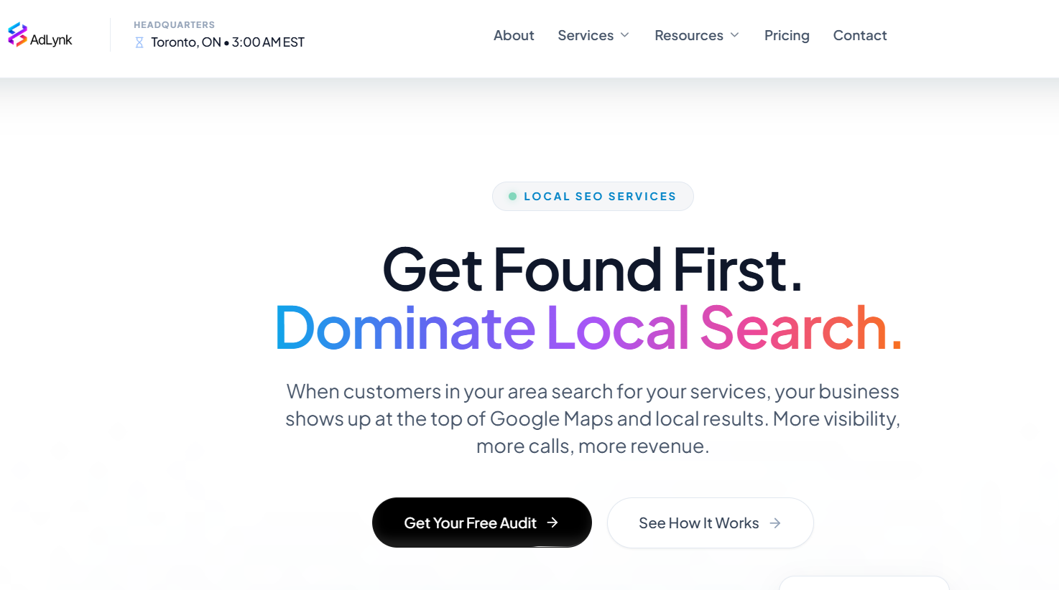
AdLynk, based in Orangeville and serving the greater Toronto area including Brampton, positions its local SEO service as part of a larger "growth engine" that connects Google Business Profile work to a client's CRM. Their local SEO package covers profile optimization, citation consistency across 50-plus directories, schema markup, and automated review-generation campaigns. The pitch is less about SEO in isolation and more about what happens after a lead calls — response speed and follow-up automation are built into the offer.

8. We Love Digital Marketing

Based in Brampton, We Love Digital Marketing runs a full-service model covering SEO, GEO, social media, PPC, and web design. Their approach to local visibility starts with understanding a business's audience and competitive landscape before building a content and Google Business Profile strategy around it. They work with businesses across several industries and publish their own blog on local SEO and AI search trends, which is a decent way to gauge how current an agency's thinking actually is.

9. SEO Resellers Canada

SEO Resellers Canada runs a dedicated local SEO Brampton program built around targeted keyword research, on-page fixes, technical cleanup, and local relevance signals like Google Business Profile and map presence. As the name suggests, they also offer white-label SEO for agencies that want to resell services under their own brand, alongside PPC and social media add-ons for direct clients.

10. 2Marketing

2Marketing is a Toronto-based agency with a dedicated Brampton service page and more than a decade of SEO experience. Their local SEO Brampton offering includes Google Business Profile setup, citation building in local directories, and location-specific keyword targeting, delivered alongside broader SEO, web design, and PPC services across several industries including dental, legal, and home services.

Why Google Maps SEO Brampton Matters More Every Year
Brampton has added roughly a hundred thousand new residents in the last five years, and most of them don't have an established plumber, dentist, or mechanic yet. When something breaks, they open Google Maps and pick from the top three results — which means every year that goes by without a proper Google Maps SEO Brampton strategy is another year of losing first-time customers to a competitor who showed up first.

How to Choose the Right Google Maps SEO Agency in Brampton
Not every agency on this list will fit every business, and that's fine — a solo trades contractor running a service-area business has very different needs than a multi-location retail brand. A few things worth checking before you sign anything:
- Ask what "optimization" actually means. Google Business Profile SEO Brampton work should include category corrections, service-area setup where relevant, and ongoing review management, not just a one-time profile claim.
- Get clarity on reporting. A good local SEO agency in Brampton should be able to show you ranking movement for the specific searches your customers use, not just overall traffic.
- Match the pricing model to your stage. Some agencies charge a flat one-time fee for map pack fixes, others run monthly retainers tied to ongoing content and citations. Neither is automatically better, but you should know which one you're paying for.
- Check who actually does the work. Ask whether you'll be talking to a strategist or getting routed through account managers, especially with larger agencies.
If you're a Brampton business trying to figure out where you currently stand, most of the agencies above — including Cremsocial — offer some version of a free audit, which is a low-risk way to see what's actually broken before you commit to a plan.

Final Thoughts
Winning the Brampton map pack isn't about picking the agency with the flashiest homepage. It comes down to whether they understand the three things Google actually checks — relevance, proximity, and prominence — and whether they'll tell you honestly what's working and what isn't. Whichever local SEO agency in Brampton you choose from this list, ask for a straightforward answer on what will change in your Google Business Profile SEO Brampton setup and how you'll be able to measure it yourself.
For further reading on the technical side of local rankings, Google's own Business Profile guidelines are worth a look, as is Search Engine Land's local search coverage for staying current on map pack changes.

Frequently Asked Questions
What is Google Maps SEO and why does Brampton need it?
Google Maps SEO is the process of optimizing your Google Business Profile and website so your business shows up in the local map pack when nearby customers search for your services. In a fast-growing city like Brampton, thousands of new residents don't have an established local business yet, so a strong Google Maps SEO Brampton strategy is often the deciding factor in who gets the first call.
How much does a local SEO agency in Brampton typically cost?
Pricing varies widely. Some Brampton agencies offer monthly plans starting around $99, others charge flat one-time fees for map pack fixes, and full-service agencies often run custom monthly retainers based on scope. It's worth asking any agency to break down exactly what's included before comparing prices.
How long does it take to rank in the Brampton map pack?
Most agencies report initial movement within 4 to 12 weeks for Google Business Profile fixes, with fuller results building over 3 to 6 months as citations, reviews, and content accumulate. Be cautious of any agency promising guaranteed rankings in days.
What's the difference between local SEO and Google Maps SEO?
Local SEO is the broader strategy — website content, technical fixes, and local keyword targeting. Google Maps SEO Brampton work is a subset focused specifically on your Google Business Profile, map pack visibility, and the relevance, proximity, and prominence signals Google uses to rank map listings.
Can a business without a storefront still rank on Google Maps in Brampton?
Yes. Trades and home-service businesses that work from a van or home office can still appear in the map pack by setting up a proper service-area profile, which hides the address and defines the coverage area instead of relying on a physical location.
Do I need a monthly contract for Google Maps SEO Brampton services?
No — several agencies on this list, including Cremsocial and RMCM, offer one-time or no-contract options for map pack and Google Business Profile fixes. Ongoing retainers make more sense if you also want continuous content, backlinks, or ad management alongside the local SEO work.
What should I look for in a Google Business Profile SEO Brampton provider?
Look for an agency that can show clear reporting tied to your actual target searches, explains what it's changing on your profile and why, and doesn't rely on tactics like fake reviews or fake addresses — both of which can get a listing suspended entirely.

